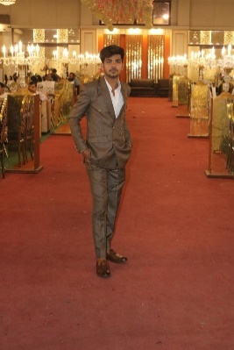
MUHAMMAD UZAIR

Address: 3A/1 Mango Pir Road Pak Colony Karachi

PERSONAL PROJECTS:

- CCNA and Networking Expertise
- To Do APP (HTML,Css,JS)

- Fully Responsive Front End multiple website -Recntly project
- Recently Project-Snake Game (javascript-Oops-Sql-)

Github:

https://github.com/uzairllc

LinkedIn:
https://www.linkedin.com/in/uzair-shaikh-5428b52aa/

Mern Stack Dev
(Modern Web & App Development)
CONTACT PHONE: 03332539739

EMAIL: shaikhuzairshaikh71@gmail.com

Objective
Aspiring computer science professional with a strong foundation in MERN stack development, eager to gain industry experience through an internship. Passionate about modern web and application development, aiming to contribute innovative solutions and grow in the tech industry and as well I wanted to gain Telecommunication technology an industry level

Education
Nazeer Hussain University – Bachelor Of Computer Science 2023 – Present
Govt: Shah Abdul Latif – Intermediate 2021-2023
ST- Micheal Convent High School–Matriculation
2019-2021

Experience

1.5 years freelancing experience and as a developer I doing working as well I used to graphic designer and 3 month researching about to Telecommunication and networking features

- MERN Stack Dev In Process : HTML,CSS,REACT JS, NEXT JS,BOOTSTRAP,TYPESCRIPT,NODE JS + EXPRESS JS,MONGO DB,POSTGRESQL
- Java script – 50% (Understand & write programs)
- C++ – 70% (Understand & write programs)
- Html-100% (Understand & write programs easily)

Skills Expertise:

HTML,CSS,JAVASCRIPT,JAVA,SQL,NETWORKING , C++,Network Configuration (LAN, WAN, TCP/IP, Routing)
Wireless & Mobile Networks (3G, 4G, 5G, Wi-Fi)

Network Security (Firewalls, VPNs, Cybersecurity) Cloud & Virtualization (AWS, NFV, SDN)

- Thank you for taking the time to review my

,Uzair Shaikh

